# Climate Change Prediction Using Artificial Neural Network (ANN)

**BY- Ronit Singh 500107871 Batch 2 AIML(Hons)**

**Daya Singh 500107846 Batch 2 AIML(Hons)**

## 1. Introduction

### 1.1 Project Overview:

This project aims to assess and predict the impact of climate change by comparing historical and recent weather forecasts using an Artificial Neural Network (ANN) model. The project involves using weather data from multiple airports to analyze trends in climate variables and project potential changes.

### 1.2 Objective:

The primary objective is to predict future weather conditions across various parameters and compare them with past records, to identify signs of climate change. The parameters under prediction include air temperature, humidity, liquid precipitation, snow depth, horizontal visibility, wind direction, and wind speed.

## 2. Dataset Description

### 2.1 Source:

The data comes from several airport meteorological stations. These datasets are expected to provide high-accuracy local weather conditions.

### 2.2 Variables:

Each dataset contains records of the following weather variables:  
1) Air Temperature  
2) Humidity  
3) Liquid Precipitation  
4) Snow Depth  
5) Horizontal Visibility  
6) Wind Direction  
7) Wind Speed

### 2.3Challenges with Datasets:

1. Inconsistent Time Intervals: Data from different airports may have varied time intervals (hourly, daily, or monthly).  
2. Missing Values: Certain weather features may have gaps, requiring careful handling to avoid bias.  
**2.4 Data Standardization:** Differences in measurement units or formats necessitated preprocessing to standardize values for accurate predictions.

## 3. Data Preprocessing

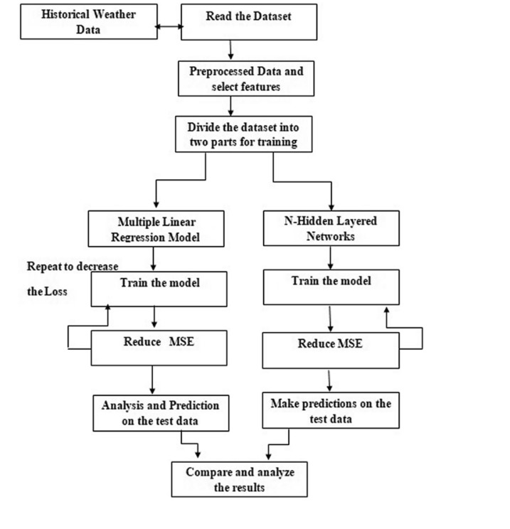

### 3.1 Handling Missing Values:

Missing data was managed using interpolation techniques to fill gaps and ensure continuous time series data across all variables. This helped maintain the temporal integrity of the datasets.

### 3.2 Time Interval Alignment:

Given that each airport’s dataset may use different intervals, resampling was performed to standardize data to a common frequency. For instance, all data points were converted to a daily interval to ensure compatibility across datasets.

### 3.3 Data Normalization:

Data normalization was applied using MinMax scaling. This transformation process scaled each feature within the range [0, 1], facilitating more stable and accurate ANN training.

### 3.4 Feature Engineering:

Seasonal and temporal features (e.g., month, day) were added to capture seasonal trends and cyclic weather patterns. This enhanced the model’s ability to capture climate-related fluctuations.

## 4. Model Architecture

### 4.1 Model Structure:

The ANN model consists of:  
- Input Layer: 7 nodes, one for each weather variable (temperature, humidity, etc.).  
- Hidden Layers: Three dense layers, each containing 64, 128, and 64 neurons, respectively, using ReLU (Rectified Linear Unit) as the activation function to introduce non-linearity.  
- Output Layer: The output layer includes seven nodes corresponding to the seven weather variables, allowing for simultaneous prediction of all features.

### 4.2 Activation Functions:

ReLU for hidden layers. Linear activation in the output layer, given the regression nature of predicting continuous weather values.

### 4.3 Loss Function:

Mean Squared Error (MSE) was chosen as the loss function to minimize the average squared difference between predicted and actual values across all weather features.

### 4.4 Optimizer:

The Adam optimizer was used for efficient training and faster convergence.

## 5. Model Training and Evaluation

### 5.1 Training Configuration:

The model was trained over 100 epochs with a batch size of 32, ensuring a balance between speed and learning efficiency. A validation split of 20% helped monitor the model’s generalization during training.

### 5.2 Evaluation Metrics:

Mean Squared Error (MSE) and Root Mean Squared Error (RMSE): These metrics provided insights into the accuracy of each predicted weather variable.  
Mean Absolute Error (MAE) was also used as an alternative evaluation metric for interpretation.

### 5.3 Validation and Cross-Validation:

Cross-validation was performed by dividing the data into training and validation sets across multiple folds to ensure robustness.

## 6. Results and Analysis

### 6.1 Prediction Accuracy:

The model achieved satisfactory MSE and RMSE scores across most weather variables, indicating that it successfully learned the patterns in historical weather data.

### 6.2 Climate Change Detection:

By comparing predictions with historical weather patterns, trends in temperature, precipitation, and other variables showed significant deviations, suggesting possible signs of climate change. For instance:  
- Rising Air Temperature: A steady upward trend in predicted temperatures over time could imply gradual warming.  
- Increased Wind Speeds and Changing Wind Directions: Alterations in wind patterns may indicate shifts in climate zones or pressure systems.  
- Shifts in Precipitation: Changes in liquid precipitation and snow depth provided insights into altered precipitation patterns, potentially due to changing climate.

### 6.3 Visual Analysis:

Visualization was key to interpreting results. Time-series plots comparing predicted values against historical data highlighted long-term trends and fluctuations, aiding in identifying potential climate-related changes.

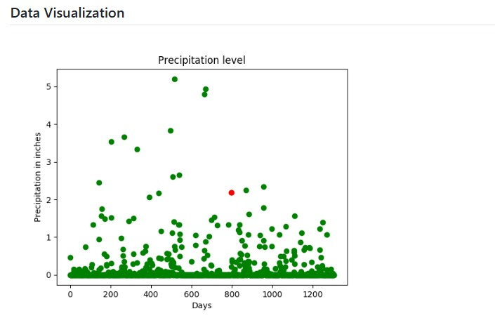

**FINAL PREDICTION-**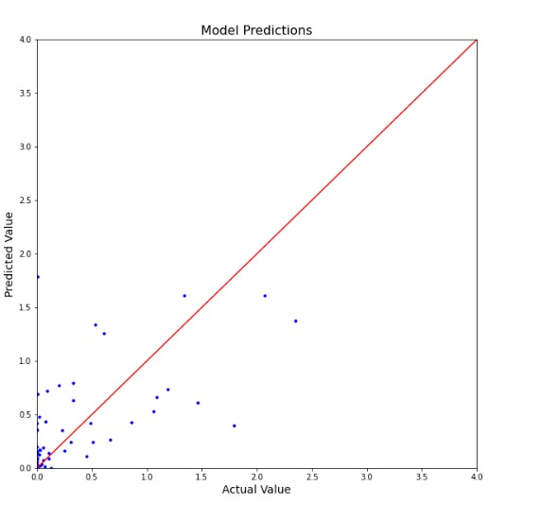

## 7. Conclusion

### 7.1 Summary:

The ANN-based weather prediction model successfully identified key indicators of climate change, capturing trends across multiple weather variables using historical and recent data from various airport meteorological stations.

### 7.2 Model Strengths:

Ability to predict multiple weather variables simultaneously.  
Adaptability to various weather datasets with inconsistent time intervals.

### Limitations and Future Work:

7.3.1 Time Interval Inconsistencies: Although resampling was applied, variations in data intervals still present limitations.  
7.3.2. Feature Expansion: Additional features such as solar radiation, pressure, and advanced seasonal indicators could enhance predictive accuracy.  
7.3.3. Advanced Neural Networks: Recurrent Neural Networks (RNNs) or Long Short-Term Memory (LSTM) networks could improve time-dependent predictions.

**8 Rainfall Prediction using Machine Learning requirement-**

Rainfall Prediction is the application of meteorology and machine learning to predict the amount of rainfall over a region. It is important to exactly determine the rainfall for effective use of water resources, crop productivity, and pre-planning of water structures. Moreover, rainfall greatly affects human life in various sectors such as agriculture and transportation. Additionally, it can cause natural disasters such as droughts, floods, and landslides. The aim of this project is to build an accurate rainfall prediction model so that prescriptive measures can be made.

Governments, communities, and individuals spend large amounts of money so that there is enough water available for everyone. Collecting and understanding rainfall data is important so that the right decisions are made. Rainfall prediction has gained utmost research relevance in recent times due to its complexities and persistent applications such as flood forecasting and monitoring of pollutant concentration levels, among others. Existing models use complex statistical models that are often too costly, both computationally and budgetary, or are not applied to downstream applications. Therefore, approaches that use Machine Learning algorithms in conjunction with time-series data are being explored as an alternative to overcome these drawbacks.

## Objective:

The main objective of this project is to identify the relevant atmospheric features that cause rainfall and predict the intensity of daily rainfall using various machine learning algorithms such as Multivariate Linear Regression (MLR), Multilayer Perceptron Regressor (Neural Network), KNeighbors Regressor, Ridge Regression, Random Forest Regressor, and Support Vector Regression (SVR).

In addition to, the Root Mean Squared Error (RMSE) and Mean Absolute Error (MAE) metrics were used to measure the performance of the machine learning models.